ASSIGNMENT-14
NAME: P.Rohan
ROLL NO: 2405A41144
BATCH NO: 06
DATE: 25-11-2024

INPUT:
from sympy import Function, Eq, dsolve, Derivative, exp, symbols
x = symbols('x')
y = Function('y')
eq1 = Eq(Derivative(y(x), x, 4) - 2*Derivative(y(x), x, 2) + Derivative(y(x), x), x**3 - 4*x)
solution1 = dsolve(eq1)
eq2 = Eq(Derivative(y(x), x, 2) + 4*y(x), exp(x))
solution2 = dsolve(eq2)
print("Solution to Equation 1:")
print(solution1)
print("\nSolution to Equation 2:")
print(solution2)

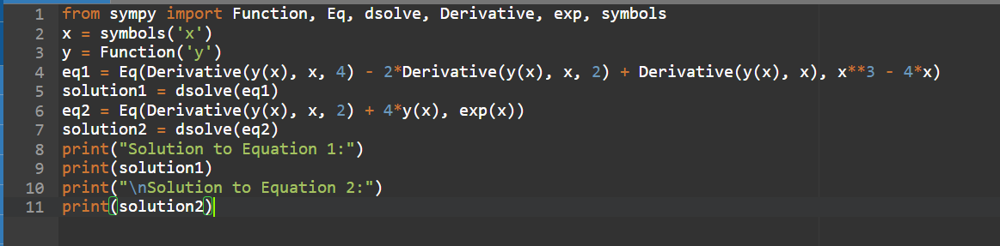
OUTPUT:

